Lab Experiments
SET -5
S. V. K. Sharon Surya
192324246

1.
# Read Dataset
traffic <- read.csv("C:\\Users\\svkss\\Documents\\DHV files\\lab exps\\website_traffic.csv")

# Convert Date
traffic$Date <- as.Date(traffic$Date)

# Line Chart
plot(traffic$Date,
traffic$Page_Views,
type="o",
col="blue",
lwd=2,
pch=16,
main="Daily Website Page Views",
xlab="Date",
ylab="Page Views")
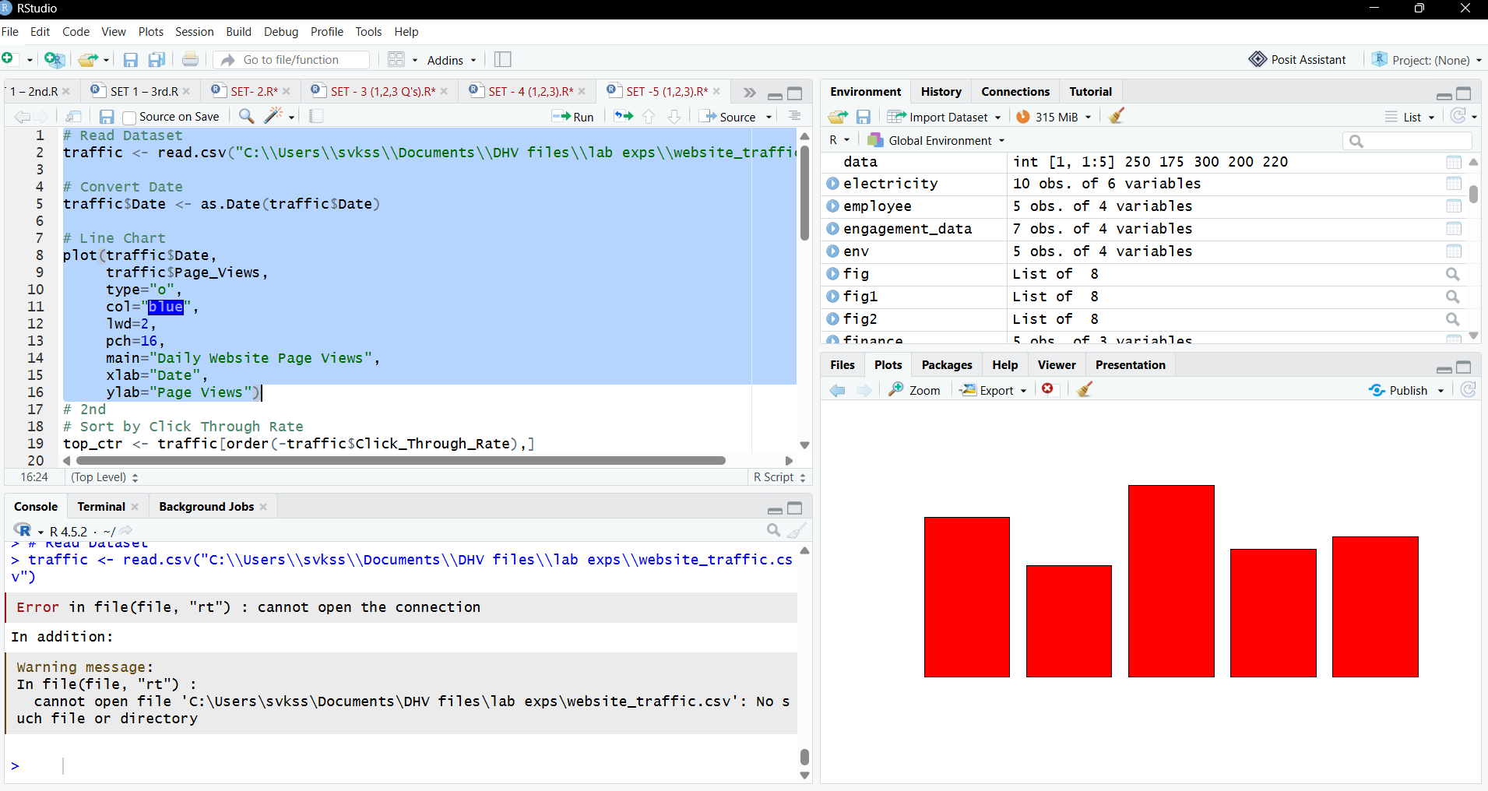

2.
# 2nd
# Sort by Click Through Rate
top_ctr <- traffic[order(-traffic$Click_Through_Rate),]

# Top 3 Days
top3 <- head(top_ctr,3)

barplot(top3$Click_Through_Rate,
names.arg=top3$Date,
col="orange",
main="Top 3 Days by Click Through Rate",
xlab="Date",
ylab="Click Through Rate (%)")
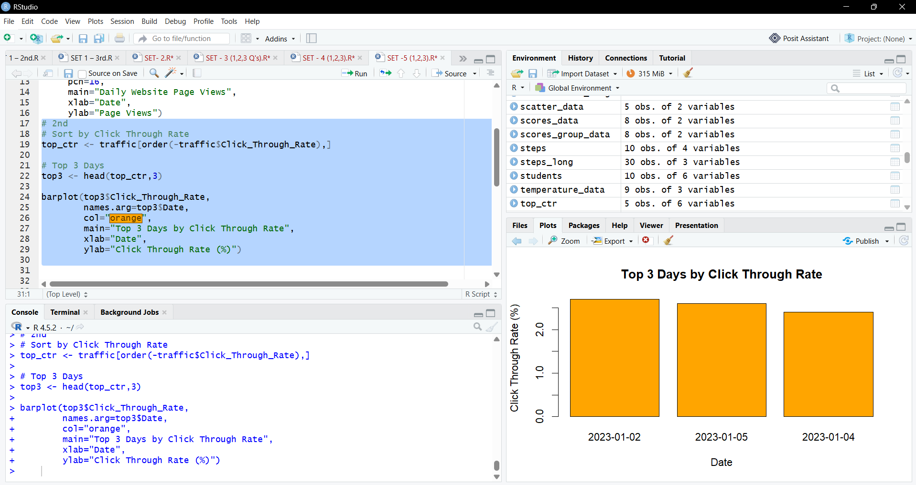

3.

# Create Matrix
interaction <- cbind(
traffic$Likes,
traffic$Shares,
traffic$Comments
)

# Stacked Area Chart
library(ggplot2)
library(tidyr)

long_data <- pivot_longer(
traffic,
cols=c(Likes,Shares,Comments),
names_to="Interaction",
values_to="Count"
)

ggplot(long_data,
aes(Date,
Count,
fill=Interaction))+
geom_area()+
labs(title="Website User Interactions",
x="Date",
y="Count")
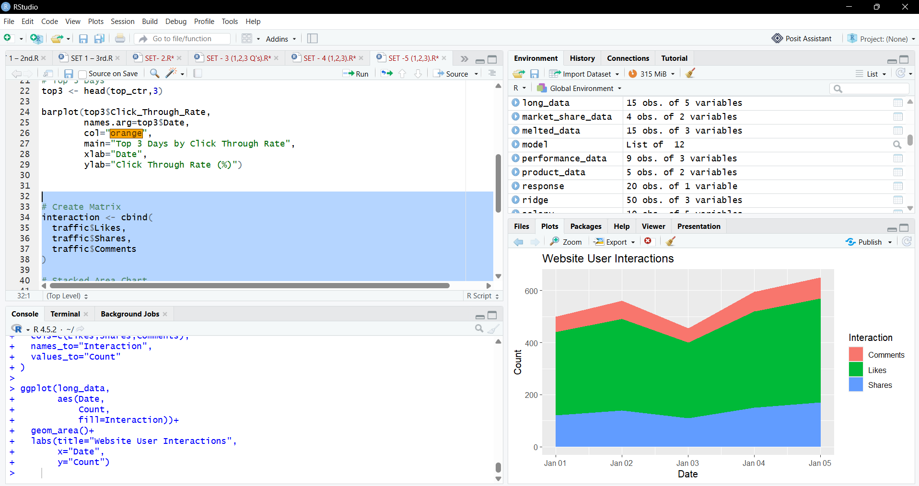

4.
